Assessment Team Report

The Assessment Team comprised of following four members visited the Department of Horticulture in order to assess its B.Sc (Hons) Degree Program on June 09, 2011:

- Prof. Dr. Abdur Rab Convener AT
- Prof. Dr. Muhammad Zubair AT Member
- Prof. Dr. Farman Ullah External AT Member

The above team in its meeting identified the following Strength and Weaknesses of the program:

Strengths:

- Foreign qualified faculty with Ph.Ds in different areas of Horticulture (Fruit, vegetables, tissue culture and ornamental horticulture)
- Laboratory facilities (two teaching/research laboratories)
- Field and Nursery facilities for on-farm research
- Collaboration with sister institution in the province like PDA, Cantonment Board, Agriculture Research Institute & Research Stations.

Weaknesses:

- Unavailability of funds for conducting research and maintenance of laboratories
- Small number of projects
- No Greenhouse facility.
- No Departmental computer laboratory for research students.
- No departmental Library.
- Shortage of class rooms
- Tissue culture lab

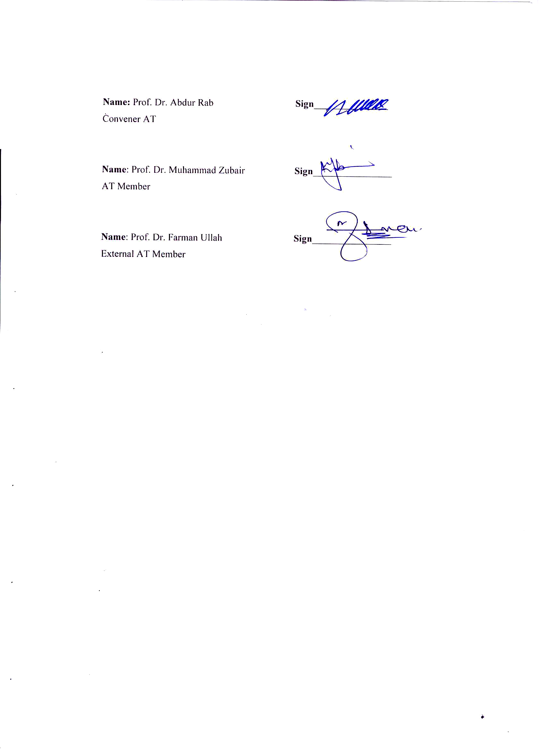
Name: Prof. Dr. Abdur Rab Sign_______________
Convener AT

Name: Prof. Dr. Muhammad Zubair Sign________________
AT Member

Name: Prof. Dr. Farman Ullah Sign________________
External AT Member

